Mc: Female

Tile set: Bright Forestry, medieval stone/concrete/hut for buildings

Enemies: monsters, Pokémon rip-off’s

NPC’s: Shop, Quest,

Gameplay: Open world with a separate map for battles. Explore the open world, random enemies with random drops. Repeatable Quests.

# Image and Sprite Sheet for one enemy



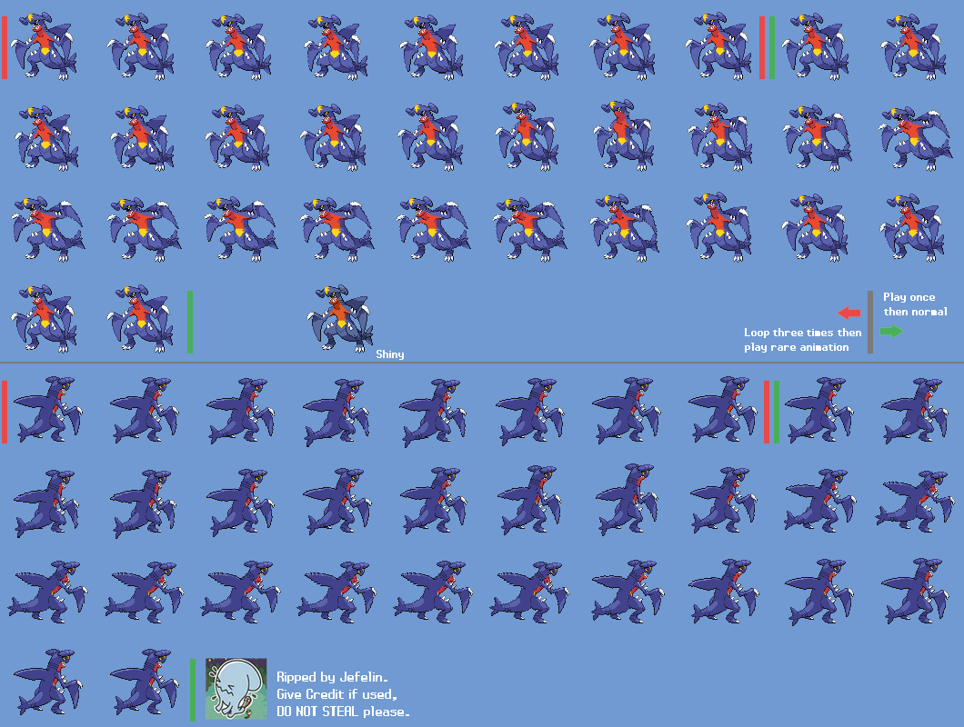

# Player Sprites

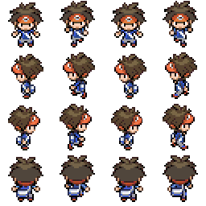

# Class Diagram

